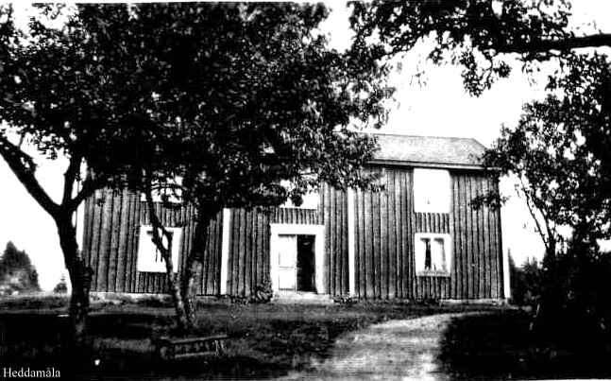

Heddamåla

**Heddamåla children**  
  
They actually came from Linneryd parish but there are so many links to Ljuder that the information about these children should fit even in a book from the hometown association in Ljuder.  
  
My name is **Bengt** Johansson and I grew up in Skruv together with my brother Arne and my sister Marianne. Our parents were named Herbert and Hertha Johansson.  
  
**Herbert** was the son of one of the Heddamåla children, named **Johannes**.  
  
**The family**  
  
Johannes's parents were named Johan Magnus Johannesson and Helena Petersdotter.  
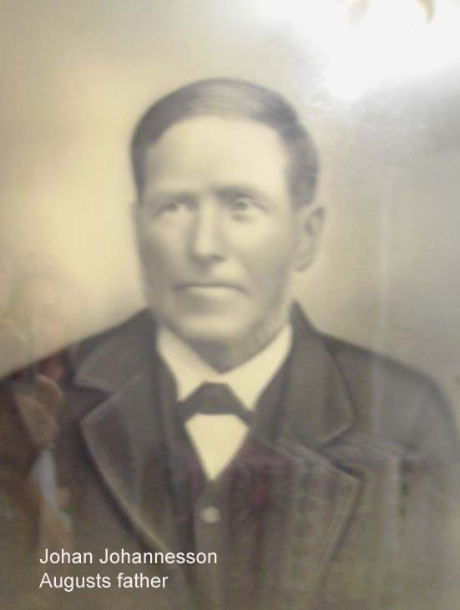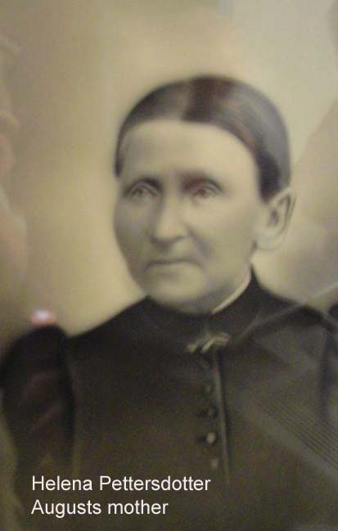

Johan Magnus and Helena

Johan Magnus was born in 1835 in Grevamåla in Linneryd parish but his family came from Älmeboda parish. Helena was born in 1834 in Hovmantorp but came to Linneryd as an 18-year-old girl where she met Johan Magnus and they married in 1860. They first lived in Rolsmo but moved to Heddamåla in 1876.

In 1861 the son **August** was born, in 1863 daughter **Ida**, in 1865 daughter **Lydia**, in 1868 daughter **Maria**, in 1871 daughter **Anna** and in 1874 my grandfather **Johannes**. They also had a son **Albin** born in 1876 but he lived only 3 months.

The son **August** asked for permission to emigrate in 1891 and emigrated to America. At the emigration, he traveled with the girl Johanna Johansdotter, called Annie, born 1866 in Vide in Ljuder. They traveled together to Stillwater in Minnesota where Annie stayed and August traveled to Shelton, which is located just west of Seattle in Washington Wa. Annie came there a little later when August built a "hut" and they got married in Tacoma, WA in 1894. August and Annie had 6 children. August died in 1931 and Annie 1948.  
  
  
  
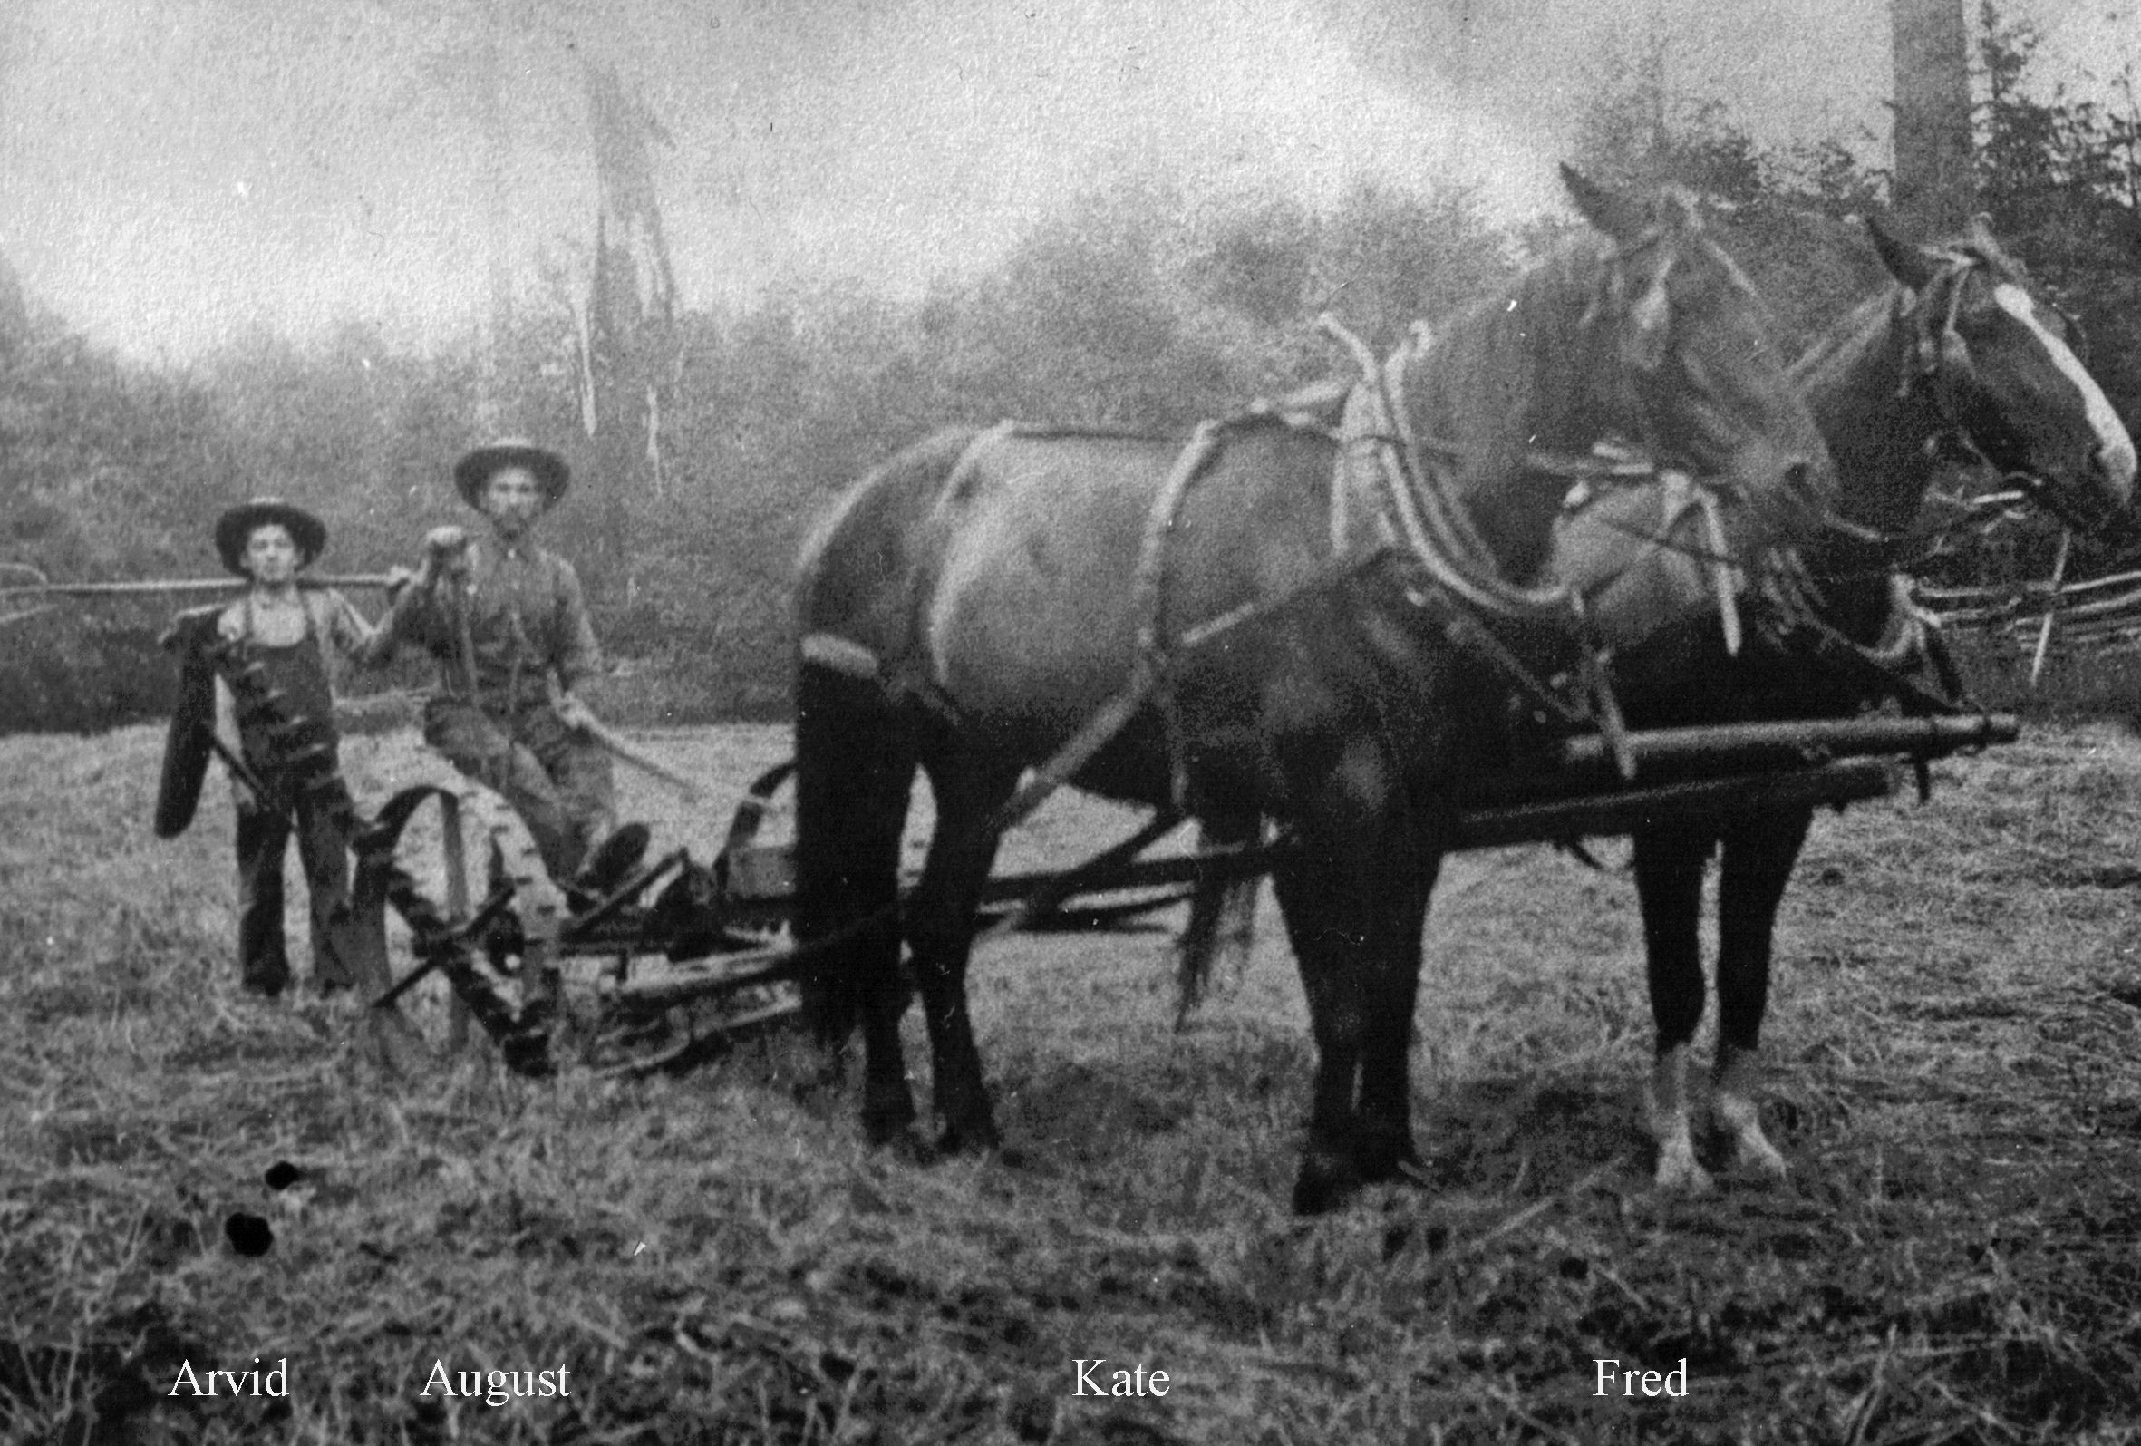

Son Arvid and August

Daughter **Ida** married Johan Carlsson who was born in 1864 at Wästergården in Skruv, Ljuder. They lived all their lives in Skruvby. They had 5 children. Ida died in 1942 and Johan in 1932.  
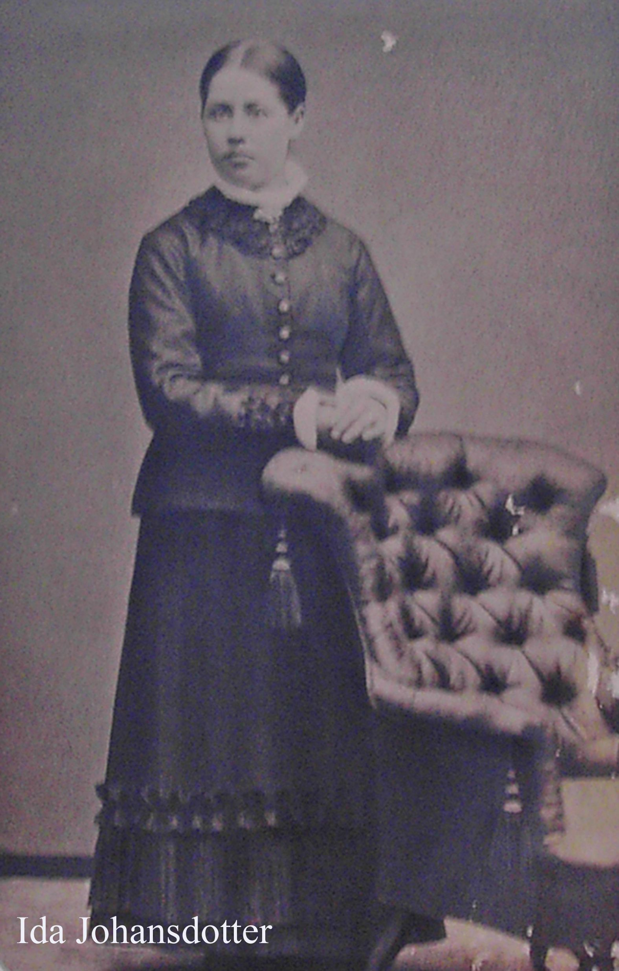

Ida

The third child **Lydia** sought relocation permission in 1901, 35 years old, from Malmö with destination Chicago via New York. She was given a job from a family in a place outside Chicago. She married Frans August Pettersson, born 1861 in Evelund, Linneryd. In the United States, he c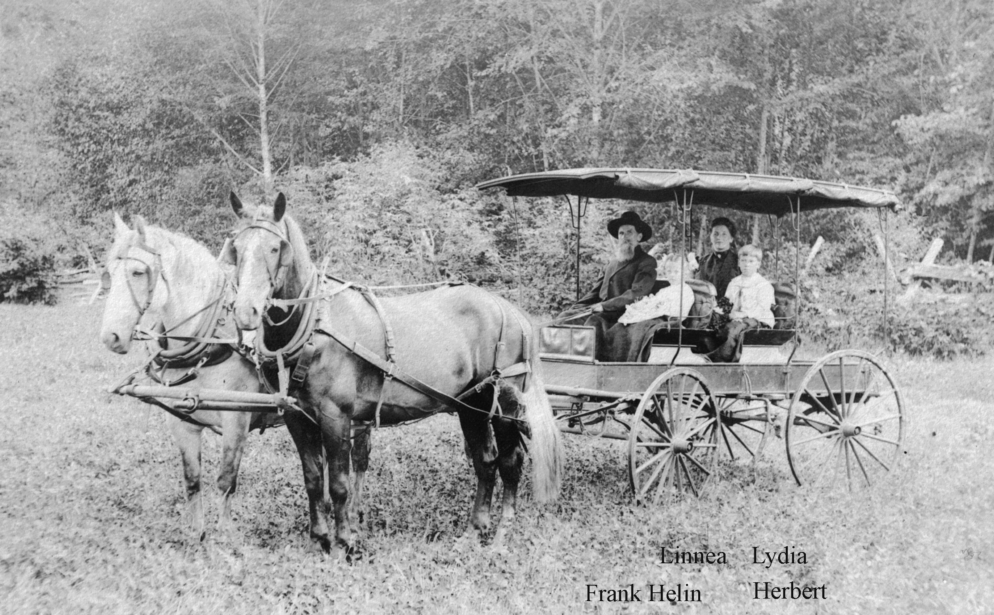alled himself Frank Helin. He probably took the surname after **He**ddamåla and **Lin**neryd. Frank had emigrated as early as 1882, first to St. Pauls in Minnesota and then went to the Seattle area. They had 2 children. Lydia died in 1945 and Frank in 1931.  
  
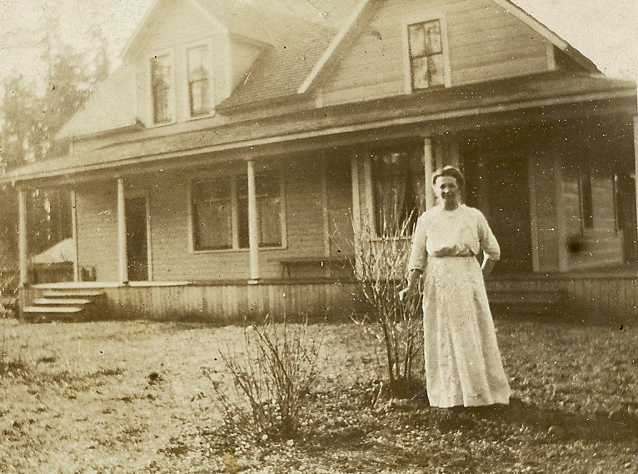

Frank and Lydia with the children Lydia in front of the home in the United States

Daughter **Maria** married Karl Augustsson, born 1865 at Wästergården in Kråksjö in the parish of Ljuder. They first lived in Tjockboda but moved to Åkerby in 1898 where they then lived all their lives. Karl had asked for permission to emigrate in 1889 but met Maria and then he changed his mind. Maria and Karl had 12 children, of whom 5 children died before adulthood. Maria died in 1946 and Karl 1947.  
  
  
  
  
  
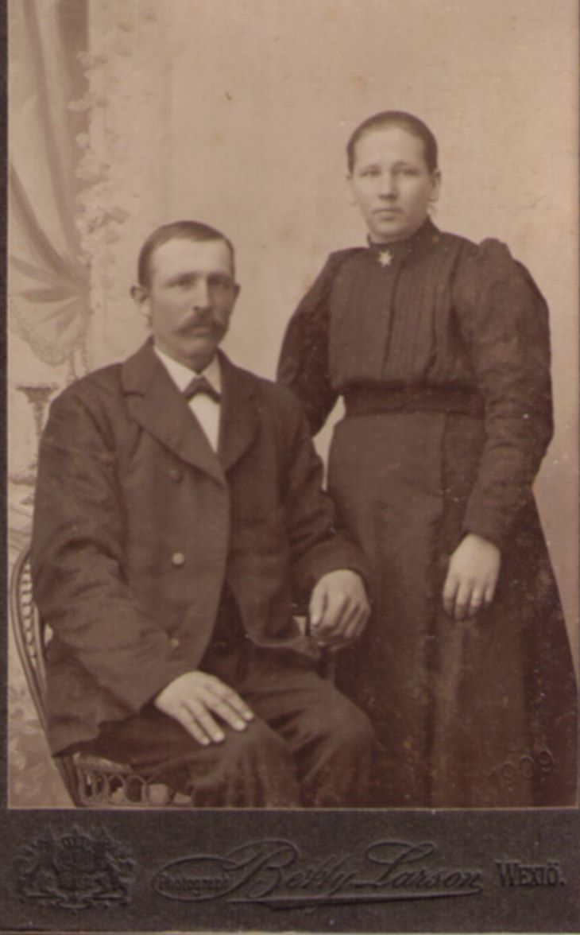

Karl and Maria

Daughter **Anna** applied for and received relocation rating in 1900 when she was 29 years old. She traveled with the steamboat Ariosto, the same as brother August went with 10 years earlier. The trip went via Hull in England, where she switched to the ship Oceanic and arrived at Ellis Island outside New York in April 1900. Also included in the passenger list was Karl Martin Samuelsson from Gummeboda in Linneryd born in 1873. They got married later that year in Chicago. Anna and Karl Martin had 3 children. The last child died already after 7 months. Anna died in 1959 and Karl Martin in 1953.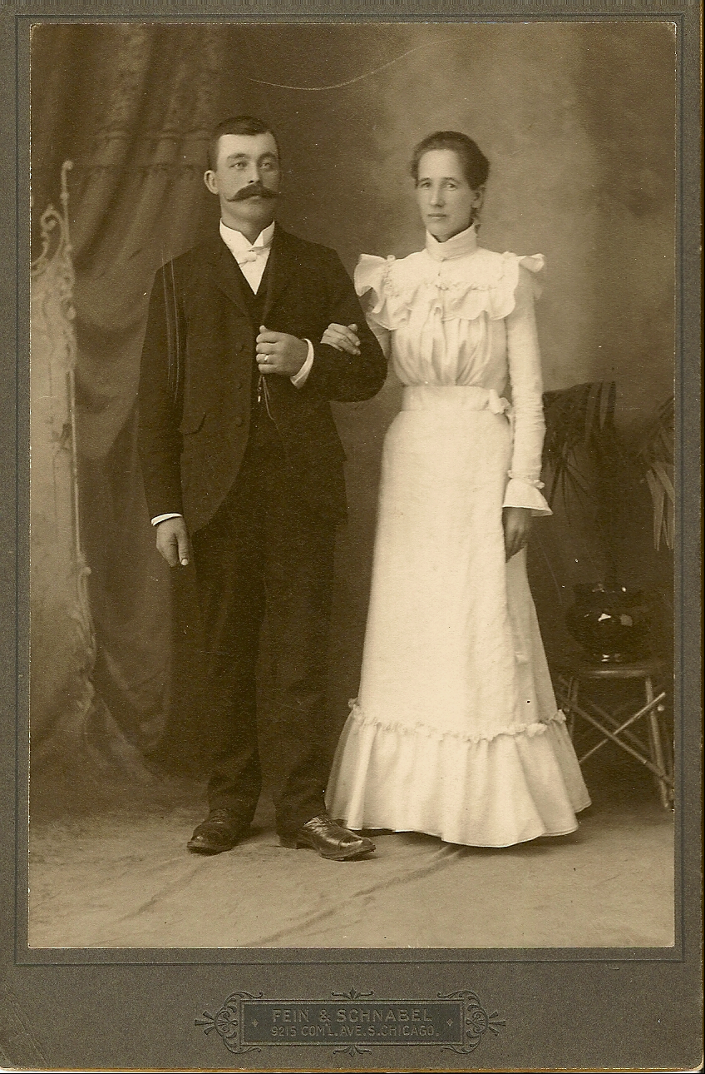

Anna and Karl Martin

The son **Johannes** married Emma Augustdotter, born in 1867, they first lived in Heddamåla with Johannas' parents but moved, as it was said, "up to the road" in Åkerby where they then lived all their lives. Johannes and Emma had 6 children, of which 2 died at a young age. Johannes died in 1958 and Emma died as early as 1942.  
  
In the past, it was often found a partner in the same village or possibly in the next village. So it was in this case. Karl and Emma were siblings and they married siblings Maria and Johannes.  
  
  
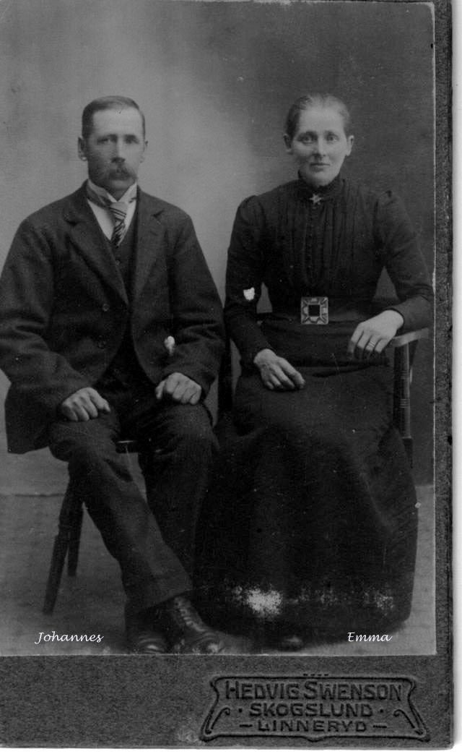

Johannes and Emma

**The contacts**  
  
Out of Johan Magnus and Helena's 6 children who became adults, three emigrated. None of the emigrant children returned to Sweden ever. The children who remained in Sweden came to live in the parish of Ljuder throughout their lifetime.  
  
During a trip that my wife and I made to California and Washington WA in 2005, we met grandchildren to Anna from Chicago and August from Skokomish outside Seattle. At the visit to the south Richard Samuelson in Palm Springs in California came with a shoe box with about 100 letters. Similarly, we received about as many letters from Wesley Johnson in Skokomish in Washington WA. Later we got to know about 50 letters through other chores. In total, there are about 250 letters covering correspondence between the siblings in the US and from parents, siblings, relatives and friends in Sweden. The letters cover most years between 1900 and 1955.  
  
All the letters have been found after sister Lydia and her son Herbert had died. Lydia had saved all correspondence throughout the years and none of the now living relatives could Swedish, so they were anxious that we would take part in the material and tell them what kind of information the letters could provide.  
  
We feel very grateful that Lydia saved everything and that we could thus have access to a family's events during much of their lives, both about joys, sorrows and problems.  
  
The parents had a strong religious belief and this came to characterize the children during their lifetime as well. In one case in the United States, there is a grandchild's son who has passed on faith and works as a pastor.  
  
Most of the letters from the first 20 years in the United States, i.e. about 1900 to 1920, describes the major difficulties that the emigrants had in the new country. Here are some excerpts from the letters that are just highlighting this and other current issues. We have retained their written language and spelling to elucidate their lives as credibly as possible.

**\* Johan Magnus**

Wrote a letter to daughter Lydia on 19th of October 1902 (NOTE the sermon held in the letter. It was the most important thing to inform about):  
  
"Loved dear Lydia thanks for the dear letter that I received for a little ago. I see that you then had the good gift of health wich is pleasing to us all to get and even we are reasonably well with health, except mother has her old cough, she as I when it comes to Winter, but we may thank God that we does not have to and league in bed then it was brought to the sessions but God puts it all to the best if we has a confidence on him then he is faithful and rectified and forgive everyone breaks cleans us from all sins by seen expensive blood and that we may support that matter one and were so we does not go most about the grace of sin because it is so important not to neglect God's grace and it is good for us to confirm the heart with The grace and that we may pray God daily and sometimes about this grace so we become more incorporated with him Jesus so that we come to live belief in him he who is the beginning of faith and perfection. He went to death for us and this applies to every times and to all of us who believe in him may not be delighted to read the Word of God and pray for each other in our prayers lets us be elusive when the groom will we be allowed to join him in the wedding room and that all of us, no one has been excluded if possible, but we will remains together in the rejection of the well being on the great day on the right side of Jesus this lend us God for Jesus Christ's sake. Amen.  
I have no news to mention for this time. We have had sewing association's baptismal kitchen and Pastor Wetterholm has been here and preached and choir Hagström from Linhöfda has been here too and has held harvest prays with the same in Linryd and Di Predikede Möcke bra. *(they preached very well)*  
A dear greeting from me and Mother and Johannes and Ema and Little Albin He has the Kickehostan *(children cough)* so hard now. Tembles by your father Johan Johannesson.  
Greeting to Anna and Martin and Ingaborg from us. Maria in Gummerbo Ljuder sends greetings to you. "  
  
  
**\* August**  
When August came to Shelton, he was assigned a piece of land, 1.6*1.6 mile which was standard in food lid. Here August first built a simple house. The land was close to Frank o Lydia Helin's farm. However, they did not own the land until you could prove that you were able to use this. In 1913, August sold the land and bought land in Skokomish Valley (at the far end of the valley) where the earth was better for agriculture than in food lid).  
  
Letter from August's sister Ida to sister Lydia on April 21, 1924 where she expresses great concern for the brother's situation: ".. Yes, I have received a letter from August, he talked about a little how he feels. Yes we couldn't help but cry, yes felt such compassion with him, he talked about it being almost 5 years since Annie got sick and Ellen has lungsot *(lungdecies)*, he says and the youngest girl has had Sharlajans fever ... " *(scarlet fever)*  
  
  
**\* Ida**  
Ida writes on 3rd of December 1925: “... It is sad times, the spirit of non believers who has such power sometimes on all people. It's too sad. I see it daily but God can change and transform the people, but he forces no one, it is our free will to choose which path. May God have the spiritual eyes opened on each one so they can see what danger it is, they go so safe. Oh what it feels sad dear sister. If I could talk to you for a while at some point but it's not to think about. It is so nice to be able to go to God with everything. Poor all people who can't take their comfort in the Word of God.

* **Lydia**  
In a letter from August to Lydia 5th October 1901 he writes: "I see that you are here in America but you have not told about who you are here with - you say with his parents but which are they, I do not know. I can understand you intend to unite yourself with an unfaithful. This is against God's Word. Then do not believe that God leads you .... I must, on behalf of God, warn you from marrying a cheating. "  
  
On 19th of October 1902, sister Anna writes to Lydia, who then worked in a family in Evenston in the state of Illinois. Her first salary was USD 6/month. Anna wanted Lydia instead to take a job closer to Chicago so that they could meet more often.  
  
However, Lydia had contact with Frank Helin who lived near her brother August and his family outside Seattle and wanted Frank to come to Chicago so that they could go to the Seattle area together. He replied to Lydia that it was a very wet spring there in 1903 so he needed to be there and treat the earth so he could put the potato. He sent her USD 33, which was the cost of the train journey from Chicago to Takoma outside Seattle. So on July 20, 1903, she went there by train. They probably got married in Takoma. There they went with a boat to Olympia and from there they probably went with a horse carriage to Matlock, where they then came to live all their lives.

Various letters from Lydia's father **Johan Magnus** J:  
10th of August 1903: “I hear and see in your letter that you have entered into a marriage association with Each other, my mother and we all get to wish you the best in your marriage and God's blessing. 23rd of May 1904: “..That Lydia has had a son. We understand you are very happy. Mother  
says that if she hadn't been so far from you Lydia, she would have been going to see you as well as the other her daughters when you got your little boy. "  
  
Various letters from Lydia's sister **Anna**:  
22of April 1923: “... You ask if we intend to go to Sweden this summer, we have not thought of that this year for now Martin has steady work and then he needs to hold on if he can have health. We see in the newspapers that there are a lot of people going to Sweden. ”  
15th of December 1923: “..... It's such a short time since Christmas was here last and yet it is a reality that you and little Linnea have been here in our home this summer, ”  
14th of February 1929: “... Albin has been at work for 7 years and Martin for 25 years. Unable to change work, many are unemployed. "  
  
  
* **Maria**  
Letter 21st of May 1903 from Father Johan Magnus J to Maria's sister Lydia in the United States: “... Maria and Carl sends greetings to you and your family. Mother says she has visited Carl and Maria for several days this winter. Maria has received a little girl. She is called Elsa Helena ... ".  
  
Maria's husband Karl wrote on 19th of February 1911 to Lydia: “... I can now first mention to you our great sadness that the loverich God pleased to call our dear sun Helgo at the age of 18 years 3 months, 12 days. He died on January 22 after a week's illness. He had a firm trust in God and that was what he had promised. The missing is great but we hope for God's great grace that he is at home and then we have the great comfort that we may meet once.  
  
I also have to inform you that our dear father in Heddamåla has been allowed to move home to the peace home that he longed for. He did as he said: “I long for all my heart to go to God”. He often mentioned you who are in America. That you are very kind to him. The day before yesterday when we were at home he was very satisfied, although small.  
  
On 3rd of November 1940, Maria wrote to Lydia: “… yes dear sister Lydia. As we know we must never meet more here on earth, we want to meet at the grace chair and finally at home with our God and Savior. May no one be finally excluded.  
  
 **\* Anna**  
On 7th of February 1904 Anna writes: "... it's seven weeks tomorrow since Martin worked some day, but we want to hope it will be something soon, but we fear it will not be good this year."  
  
Anna writes on another occasion that her daughter Ingaborg was very ill. They should have taken home a doctor but they could not afford to pay the doctor's visit. Luckely, she got better with the treatment they could give her.  
  
In letter 6th of May 1906 Anna writes about her son Arthur's funeral (only 7 months old) and that Martin's parents wanted them to go home and take over the farm. They are considering but think they have too little money left when they paid the trip.

On 8th of July 1907 Anna writes that they moved to Chicago Heights 6 weeks ago.  
The apartment is in 2 rooms and a kitchen, a small hall, no toilet or bathroom and no wind to  
hang the clothes in. It is low to the ceiling on the second floor. The apartment cost USD  
12/month. Inside Chicago they paid USD 10/month.

Anna writes 8th of August 1908 to Lydia: "Father says he thinks it would be better we traveled home now while the bad times are and I am almost highlighted, because I think it would be better to take the money for the home journey, than to be here in summer without work, because then we have at least seen the dear parents and it would be worth the trip. And then, if we live and come back again, then we are as the first time when we came here and that is true. Then we have no home or anything. But it is good to be able to present even that thing for God our Father, the one who has set the way that we will go, while we are here and he can join in and lead our steps and our will, it will be happy and well for us. "

In letter 30th of January 1911 Anna writes that she/they are considering going home to Sweden. Martins Brother Wilhelm wants that and he will get married, but Martin and daughter Ingaborg are not feeling well. Martin does not want to go home. He says he has no home there anymore.

On several occasions Anna writes that she thinks that Martin gets far too poorly paid on his work and that he should demand more money. Martin's answer that if he complains, they just say he can leave. There are so many who are unemployed and who are willing to take his job.

Almost all letters are about Anna's homesickness, about how lonely she is in Chicago, how much she lacks her parents, other siblings and that Lydia and August in Washington have each other. In addition, she writes a lot about her faith and that everything that happens is God's will. For example, if God wants them to move home to Sweden, it will be so.

On 13th of March 1911 Anna writes to Lydia: “..Dear sister you say you have received no letter from Sweden this year, but I think you and August have received now, as well as we, and if you have not received anything I will tell you that you can never get anything more from our dear father, he who has been so faithful to write to us all the years we have been here. He has now had to leave all the work and as we probably know, had to go for bliss and rest in the arms of Jesus. Oh what better we could wish for him. Now he is eternally salvaged from all the suffering here. But it is so hard to think about our old dear mother, who has become alone. "

* **Johannes**

On March 10, 1905, sister Anna writes to Lydia that their father sold the farm in Heddamåla to Johannes.

Johan Magnus writes 11th of September 1905 to the daughter Lydia the following regarding the sale of the farm: "You asked in your letter how much I would get for the farm. I would have SEK 5000. Then we would live at that end of the building to housing, part in Kitchen and baking oven, a stop sweet milk a day in both of our lifetime, 1 liter of cheese and butter a year, 6 arms birch wood, chopped and embedd. Thought to sell the yard to someone else I would have got a little more, but they were so assertion about it and wanted to bay the farm and stubborn that I would sell the farm to them. Mother she did not want to move from Heddamåla until they carry her in the grave. "

In 1921 Johannes moved with the family to Åkerby. On the property was later Johannes son Lage and Gustav Johansson's wood processing factory installed in year 1930. The plant included saw houses, planer and machine house. The work consisted mainly of sawing of purchased root posts and logs from the resort's farmers.

In Ljuders hometown book 2015 there was an article about Johannes and Emma's son Lage. The article was entitled "Lage Johansson - a life as an entrepreneur", written by Lage and Irma´s sons Kenneth and Ivan.

**TERMINATION**

Since we thought it was important that the material we had to share could also benefit current relatives in Sweden and the United States, we decided to post the information we provided on a website on the Internet. There is about 150 enrolled letters from the originals (in Swedish and English), a lot of pictures and some examples of the original letters that have been scanned. Part of the material has been judged to be of a private nature and then a password is required to take part in them.

Since we became pensioners, we have devoted a lot to genealogy, both on my and my wife's side. We have also posted this on the website.

The website and its material find those who are interested during www.bjsig.se. If you who read this want to get in touch with us, you can do so via email account bengtjohans@gmail.com.